Stakeholders can be considered as those groups or individuals that have interest relations with the organization. Additionally, stakeholders and organization depend on each other to realize their own aims. However, different stakeholder may have conflicting expectations, thus we attach importance to stakeholder analysis.

Then, I will focus on analyze the nature of interest and power of four kinds of stakeholders and suggest what strategies should Starbucks take to obtain their royalty.

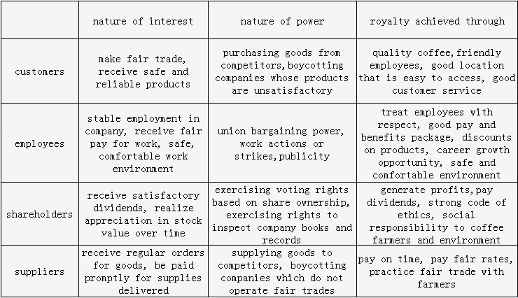

In fact, for these four types of stakeholders, Starbucks have adopted different effective strategies to improve stakeholder expectations.

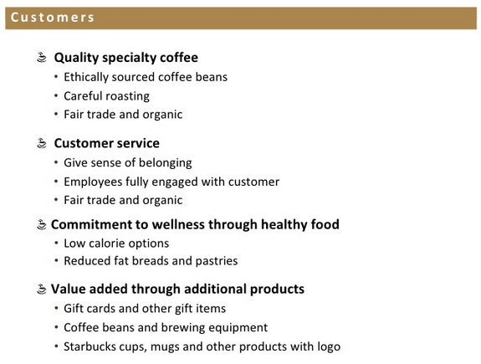

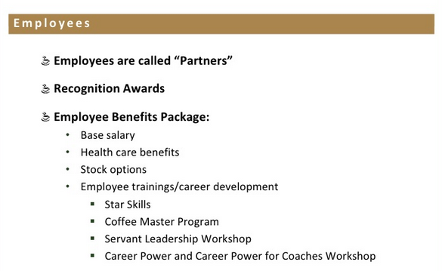

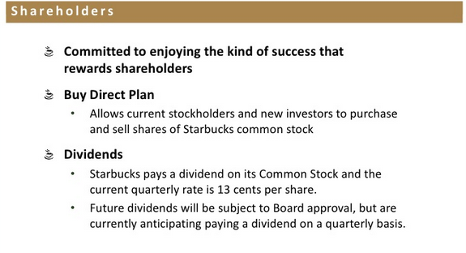

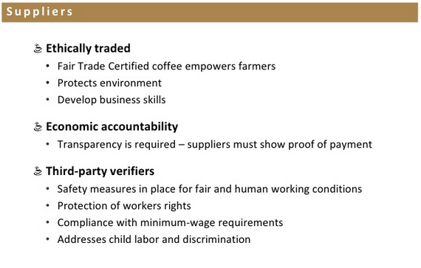

From the above information, the likely stakeholder mapping is presented as follow:

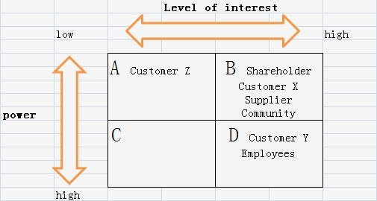

First of all, due to large amount of customers of Starbucks, customers are divided into three types: people who are strongly in favor of the strategy (customer X), people who are largely hostile (customer Y) and people who do not care the strategies of Starbucks ( customer Z). Apparently, both customer X and Y have strong interest on strategies while customer Y pretends to have much more power than customer X, for instance, through lobbying or demonstrations. However, Customer Z has neither much interest nor power on strategies. Secondly, as for employees, called as “partners”, are offered great benefit package and satisfying paid, which makes them become live advertisement for their company. Thus, employees should be the key players to strategies. Thirdly, it seems that shareholders have great interest on strategies but have limited power because of the separation of ownership and management. Additionally, Starbucks do trade with suppliers ethically and make sure about their benefits. That means suppliers have great interest instead of power on strategies. Finally, reflecting from the experiences of strong combat of entering Brazil market and opposition of Chinese when admitted to the Forbidden City in Beijing of China, communities have become indispensible factors in stakeholder mapping. People in communities are possibly interested in the strategies of Starbucks since they suppose their benefits may be deprived due to entry of Starbucks store, though they have little power to affect strategies.

According to the stakeholder mapping, Starbucks can make minimal effort on Customer Z, and keep group B informed. As key players, customers Y and employees will have the most influences on the strategies of Starbucks, hence much attention should be paid to them. What’s more, supplying ample information to group B is very necessary because they might affect the attitudes of key players through lobbying.

In my opinion, the preferred situation of stakeholder mapping should be:

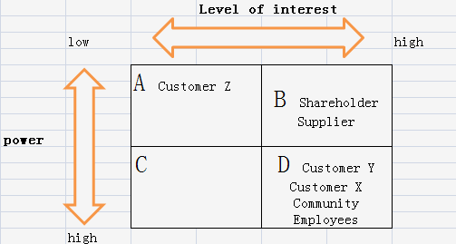

Starbucks could take some measures to change the stance of specific stakeholders to a more optimistic one and to enhance the power of them. For instance, customer X can be stimulated to bolster the proposed strategy and help Starbucks by supplying media access, or even convincing customer Y that the change can be good. Also, if community, which represents the attitude of local people to Starbucks, could be shifted to group D, it will become one of the important indicators for Starbucks’ decision to locate their stores. Community mainly determines the popularity and acceptability of Starbucks in local, so Starbucks can make use of this truth to gain more benefits by increasing connection with customers and community. Therefore, I put forward the following recommendation to further enhance connection with customers and community.

Starbucks could decorate digital picture frames in all stores and upload local customer photos and perhaps even family photos supplied by customers. Digital picture frames are able to hold thousands of pictures which would turnover regularly throughout all day. Such digital picture displays doesn’t cost much. They would not require major amendment to any stores and would have an immediate effect on improving the family atmosphere, because Starbucks gives people an opportunity to personalize their local coffee store and join a community.

Apart from, to achieve customers’ loyalty towards Starbucks, it is important to keep a reputation for the highest quality coffee in the industry. In February of 2012 the magazine Consumer Reports rated McDonald's drip coffee as tasting better than that of Starbucks. To make sure the quality of their coffee, Starbucks should continually analyze their brewing systems and think about innovations. The brewing process should at all times be judged based on its ability to bring out the complexities and distinguished flavours of the world’s different exotic specialty coffees. Starbucks should also be conscious to protect whatever brewing process they deem to be the best through patents or acquisition of patents, which would, in turn, provide a defensible competitive advantage.